
www.raccefyn.co
Supplementary material
In silico identification and characterization of transcription factor binding sites
upstream of the human PDGF gene
Identificación y caracterización in silico de los sitios de unión a factores de transcripción aguas arriba del gen PDGF humano
Víctor Eduardo Rojas-Pérez, Eduardo René Parra-Villegas
Correspondencia: victor.rojas.03@alu.ucm.cl

Table of Contents
Figure S1

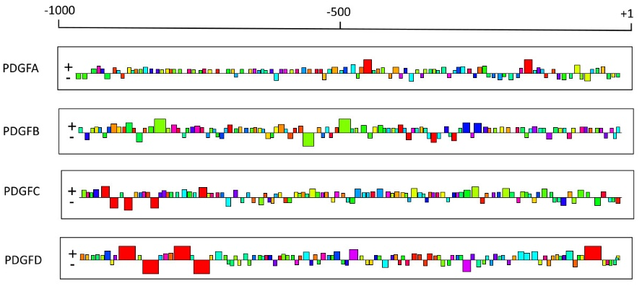
Figure S1.- Distribution of PDGF gene promoter sequence motifs in both forward and reverse from position +1 to 1000 bp.

